Chapter 3, Problem 75.

Use PSpice to solve Prob. 3.58.

Chapter 3, Problem 58

Find i₁, i₂, and i₃ the circuit in Fig. 3.103.

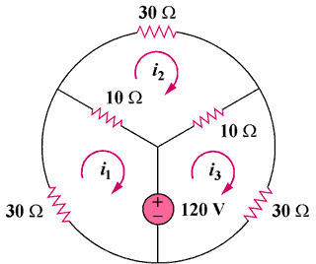

Figure 3.103
For Prob. 3.75.

